Assignment 1

Exercise 1:

Input:

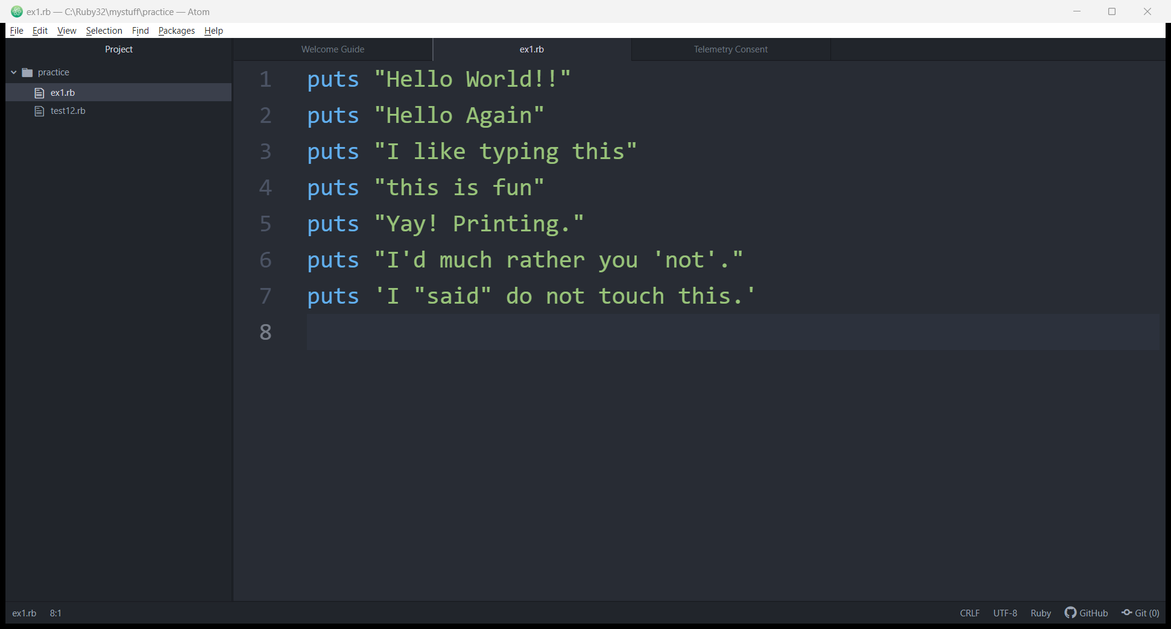

Output:

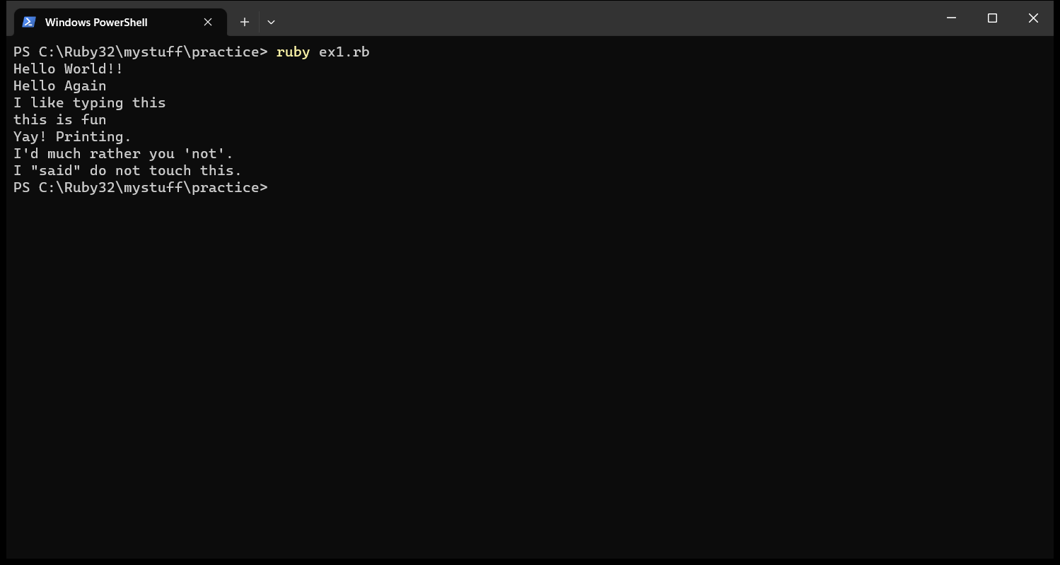

Exercise 1.1:

Make your script print another line.

Input:

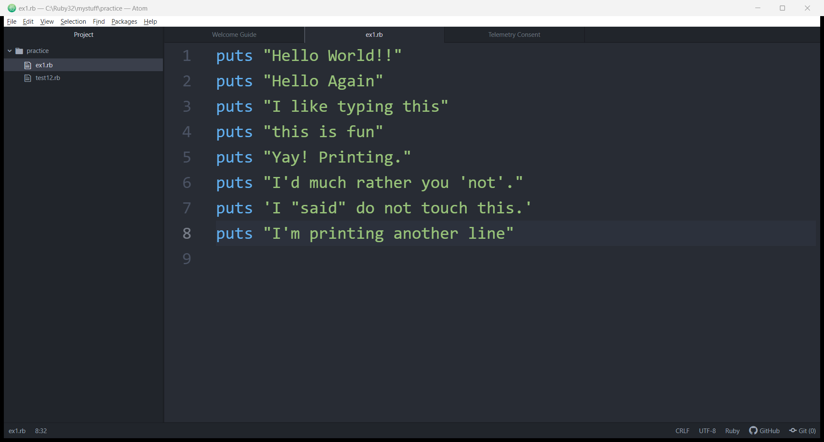

Output:

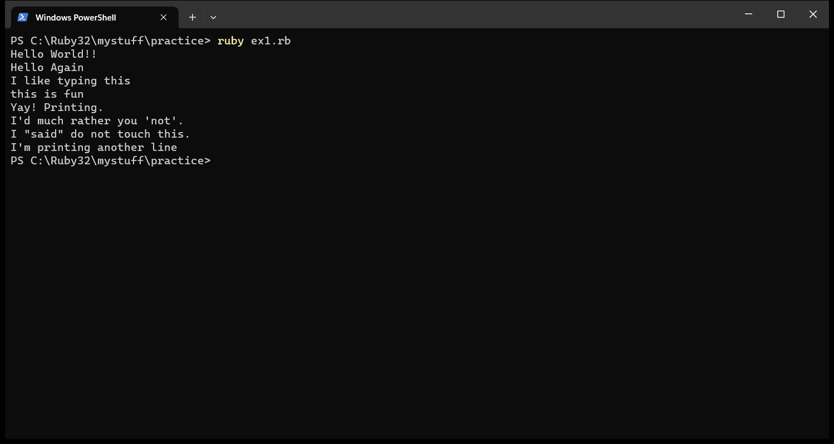

Exercise 1.2:

Make your script print only one of the lines.

Input:

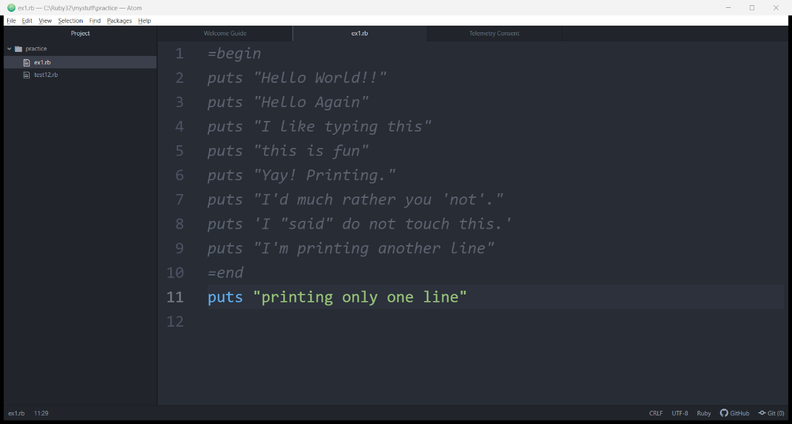

Output:

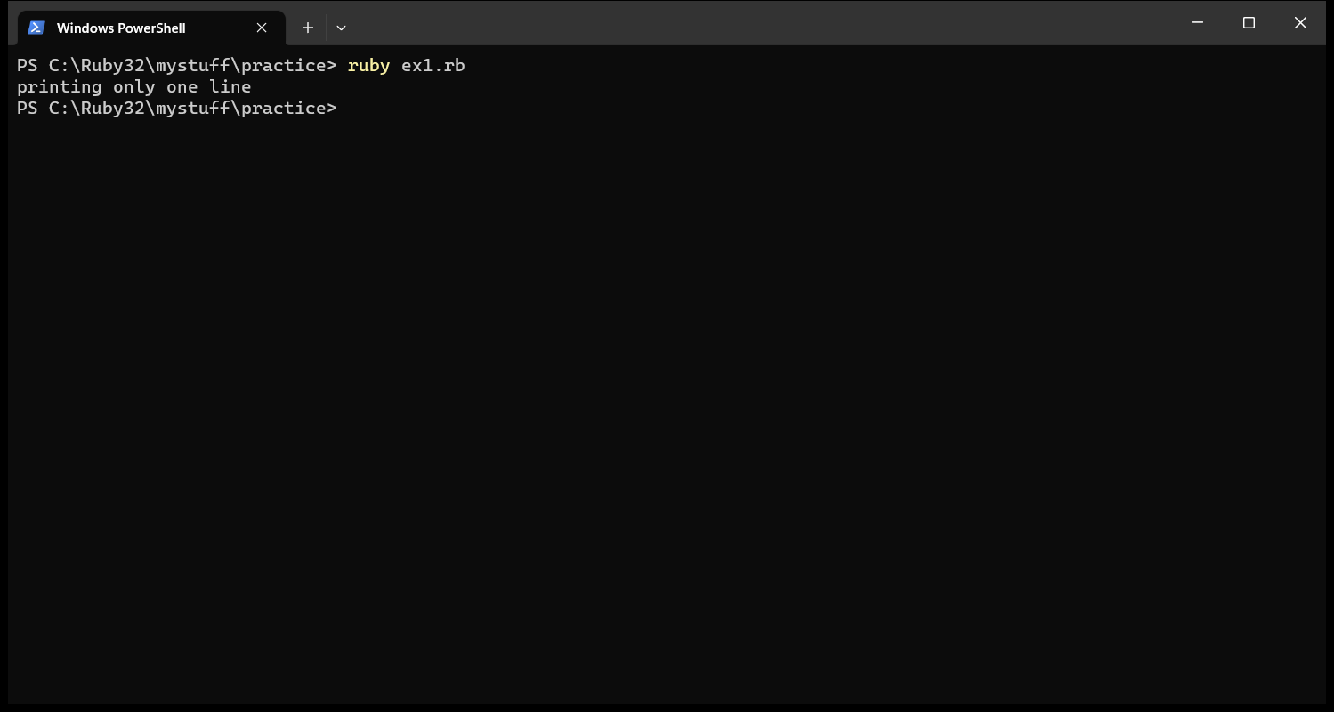

Exercise 1.3:

Put a # (octothorpe) character at the beginning of a line.

This becomes a single line comment.

Exercise 2

Comments and Pound

Input:

Output:

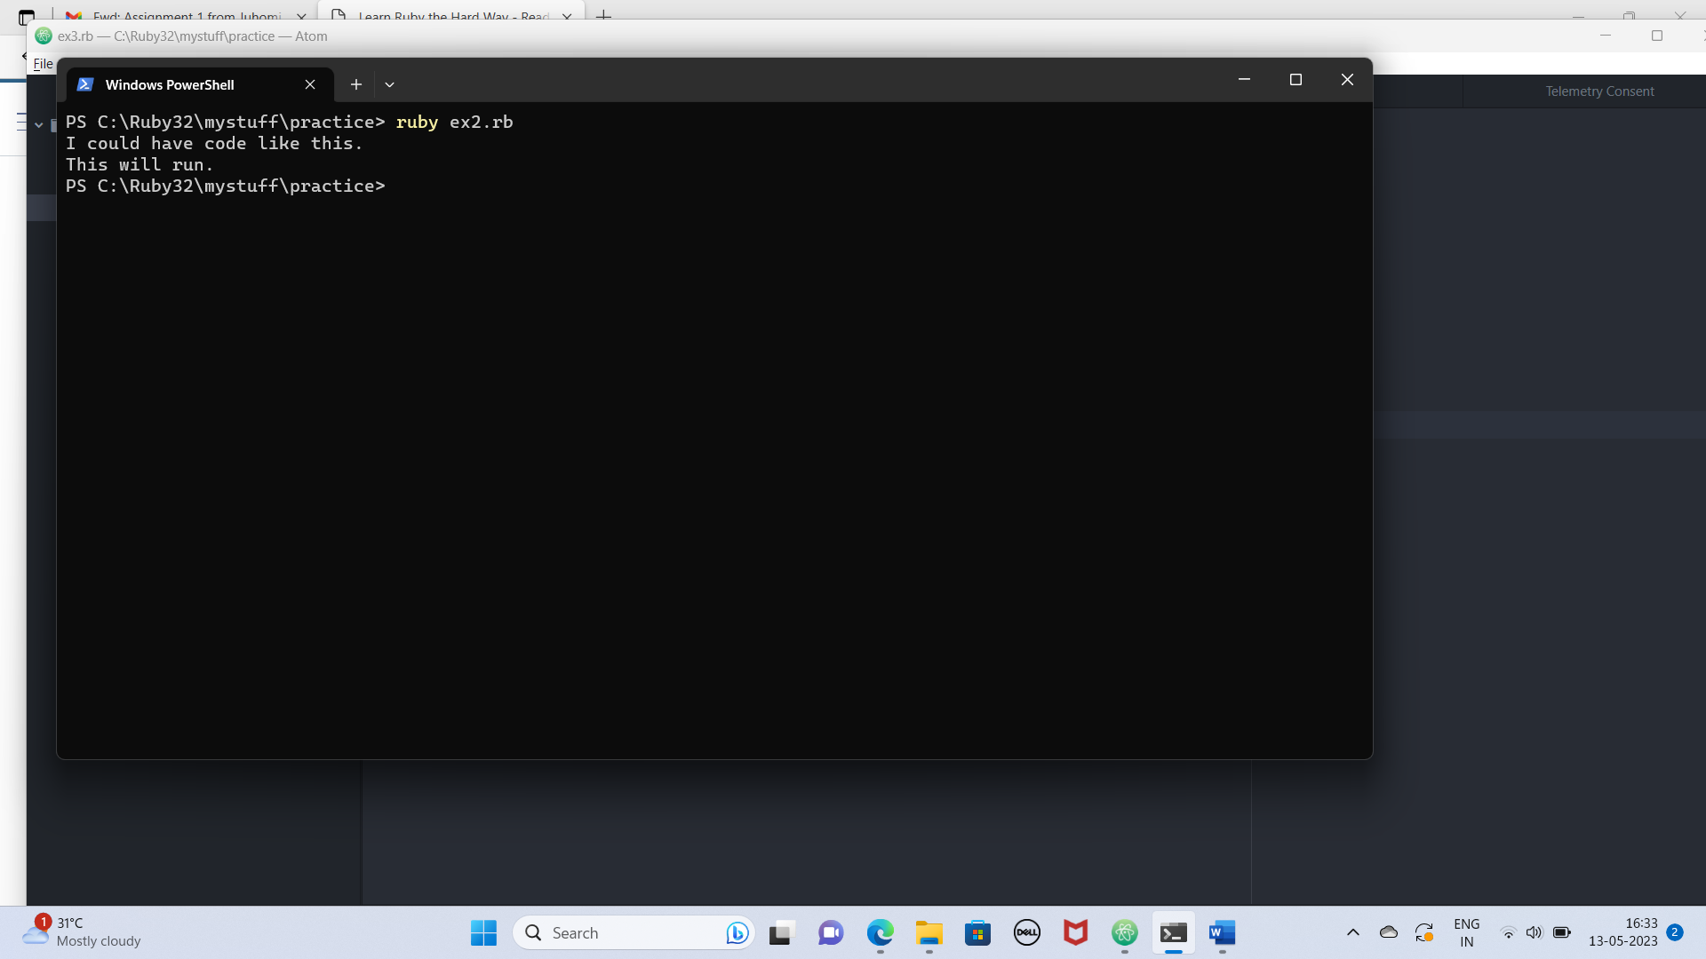

Exercise 3:

Number and Math

Input:

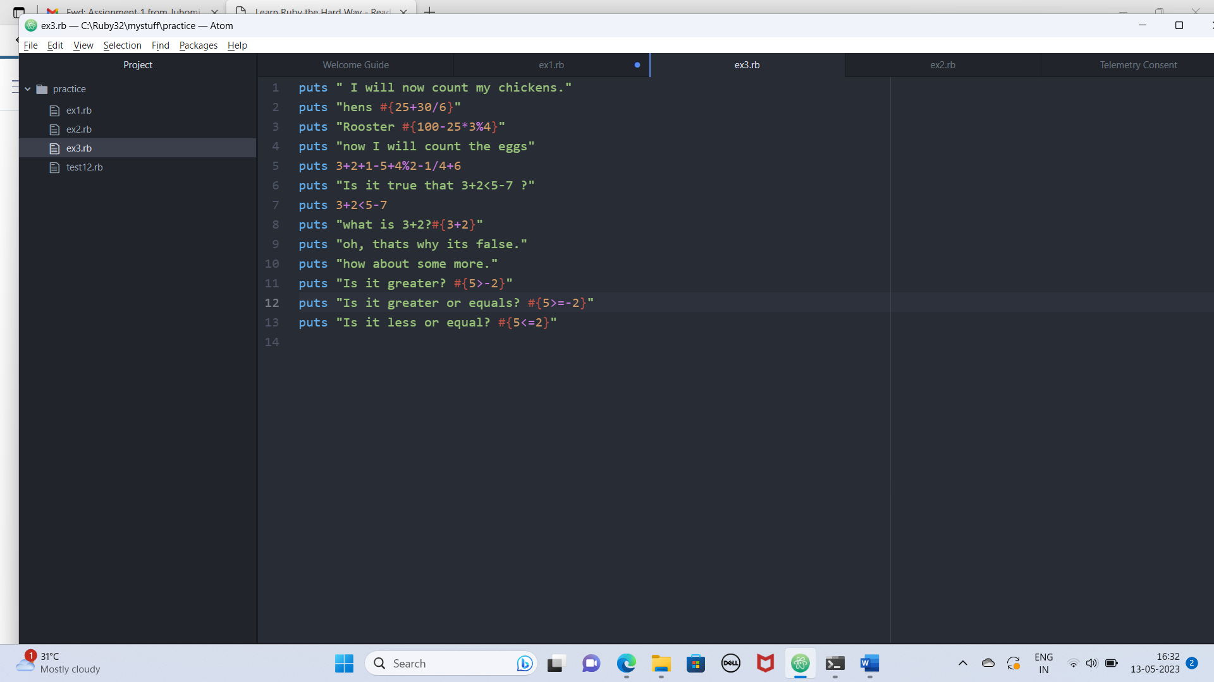

Output:

Exercise 4:

Variables and Names

Input:

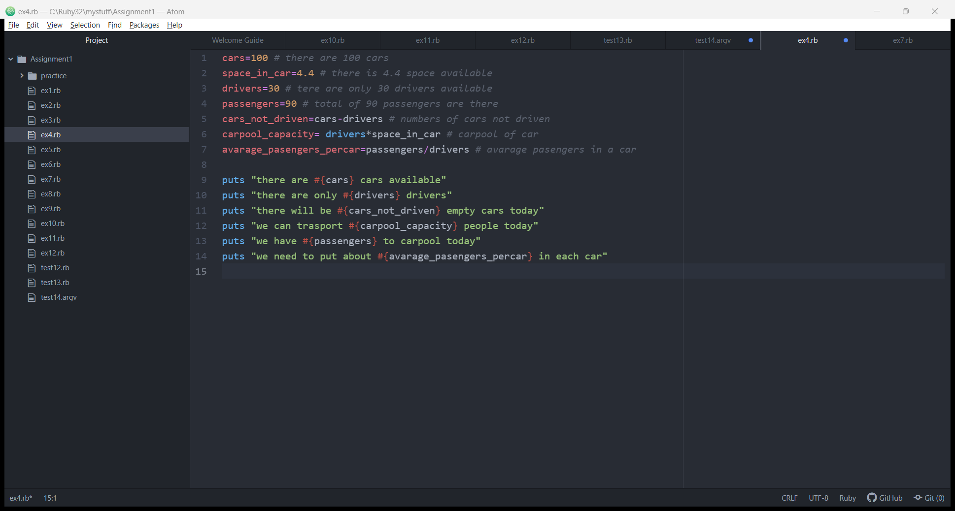

Output:

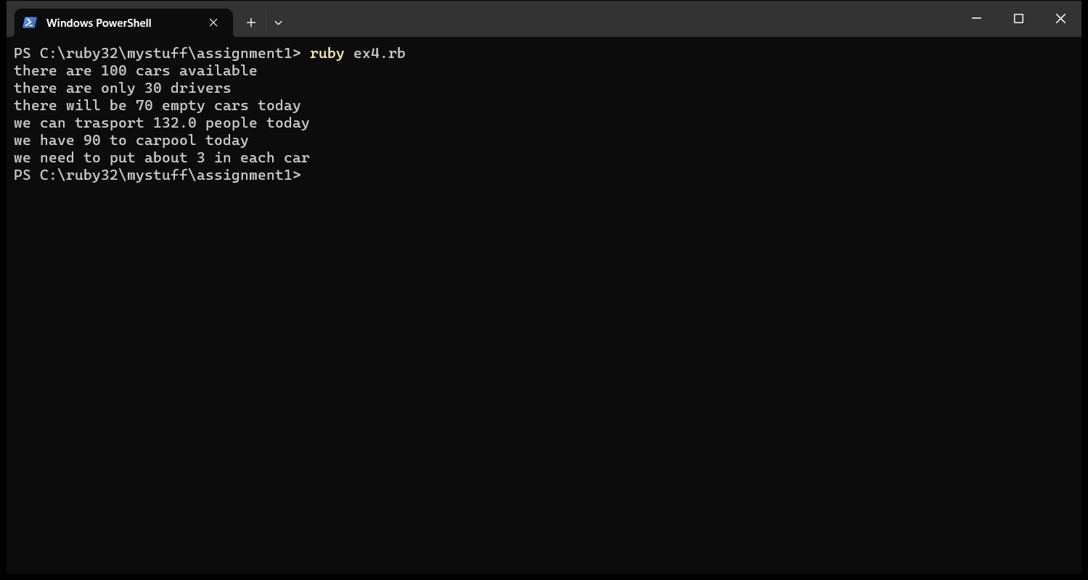

Exercise 5:

# More Variables and Printing

Input:

Output:

Exercise 5.1 and 5.2 :

Input:

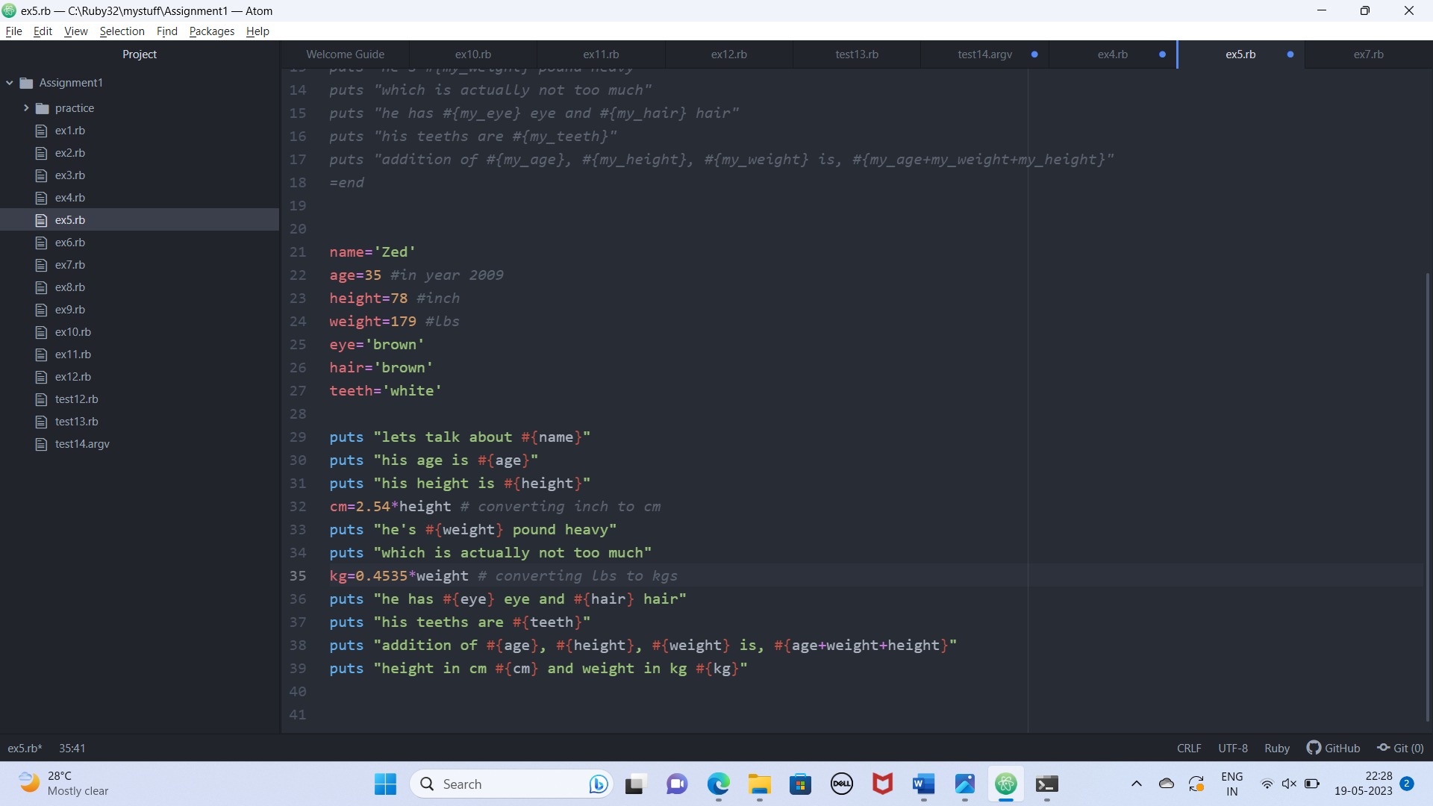

Output:

Exercise 6:

# Numbers and Math

Input:

Output:

Exercise 7:

# More Printing

Input:

Output:

Exercise 8:

# Printing, Printing

Input:

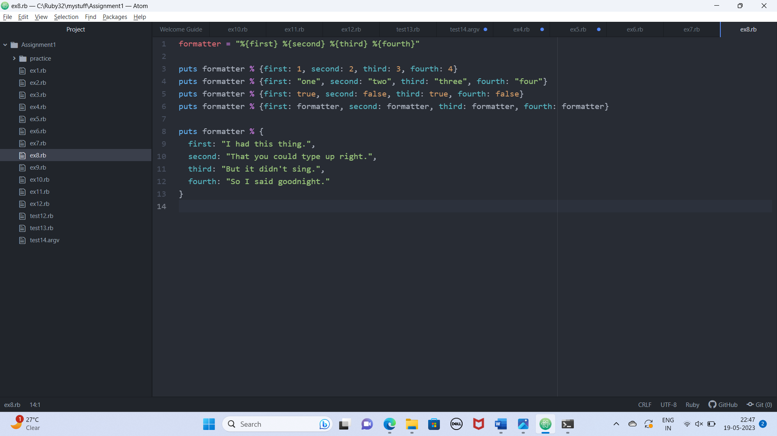

Output:

Exercise 9:

# Printing, Printing, Printing

Input:

Output:

Exercise 10:

Input:

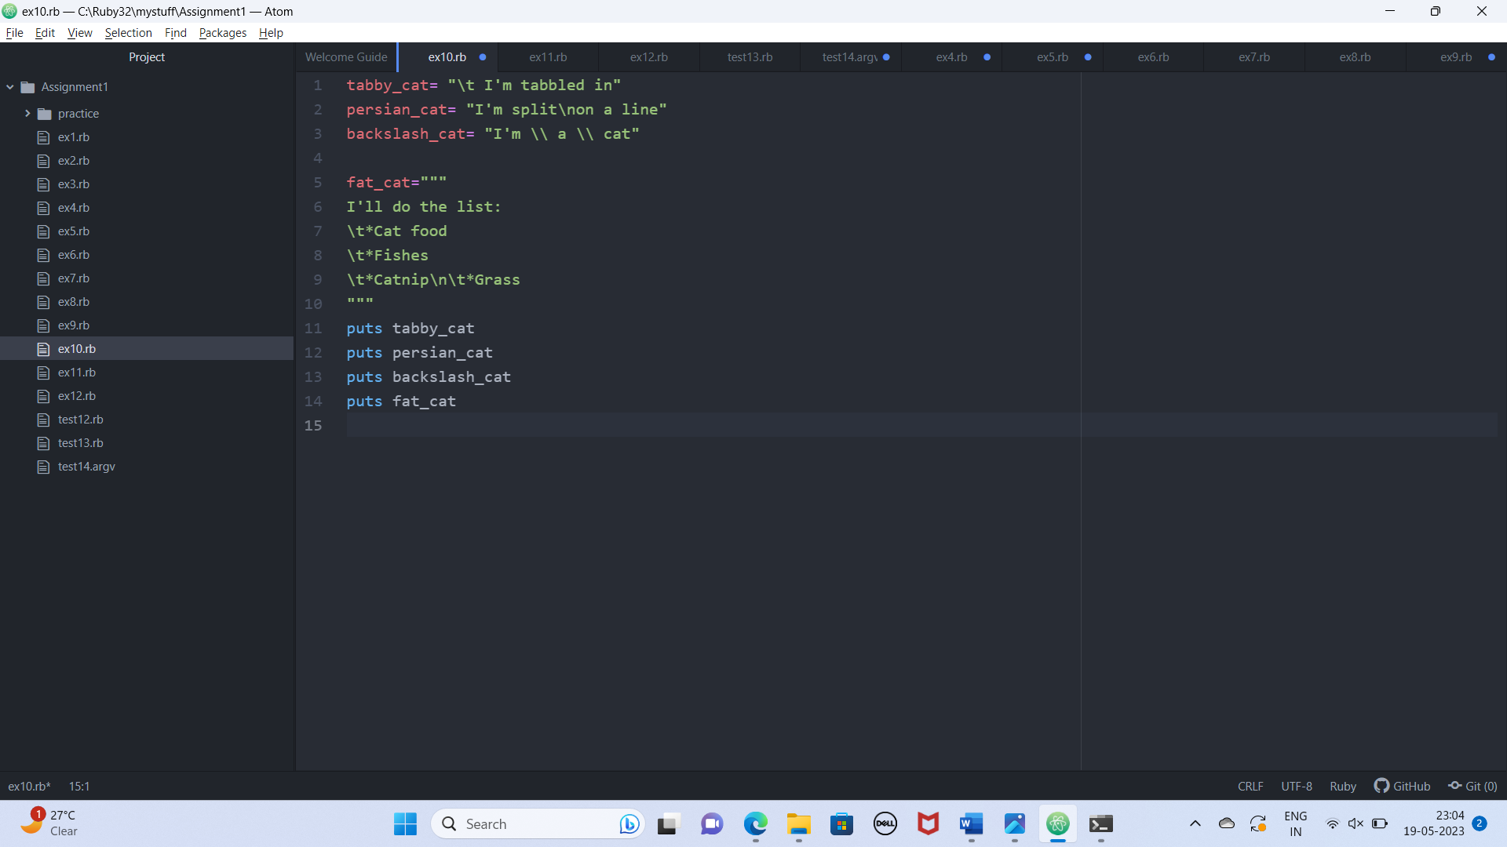

Output:

